Hi Sunny –

The animations and charts are looking great – thanks so much for implementing!

I’m wondering if we can also make the following modifications…

1 – Dots sometimes appear and disappear during the initial few days of the chart

When the animation first begins for the chart, in the first few days of the animation, some of the dots flicker in and out. For a day or two of the animation a dot will appear for a country, and then will disappear for a couple days, and then come back again. Is it possible to fix this somehow? It seems like an odd behavior to have. I’m wondering if its perhaps because of the data. Is there day missing for some countries in the early days of its history? The problem is most noticeable in the countries of central American on the map… I’ve highlighted them below in the screenshot.

Also, sorry for being so particular about it. I plan on using the graphics / charts in a demonstration to a company to try and secure them as a client and the added details I think can go a long way here.

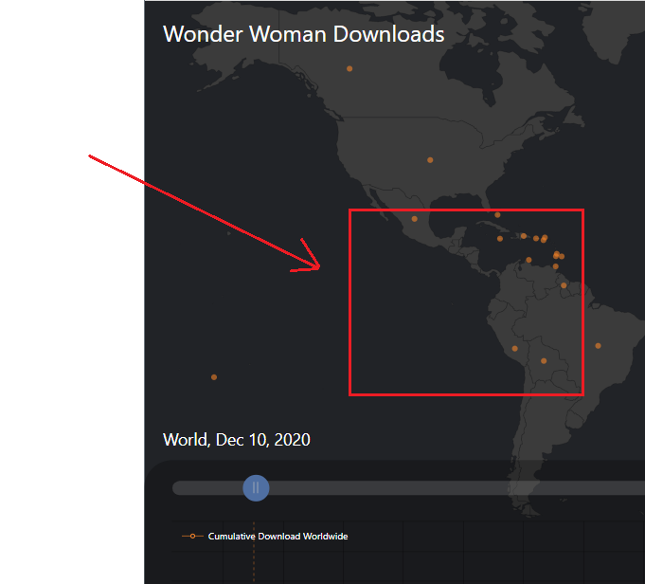

2 – Annotations on the animated chart

Is it possible to add annotations to the chart such as the example in the screenshot below?..

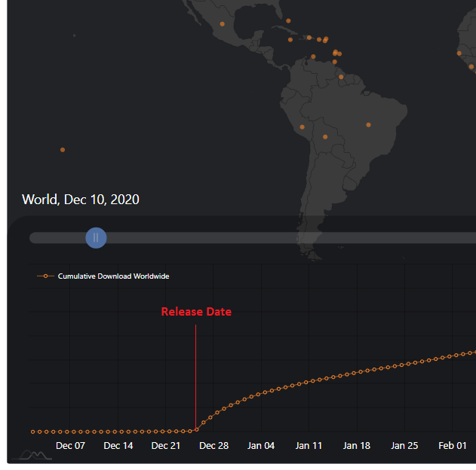

3 – is it possible to change the bullets points on the new line charts to the style below?..

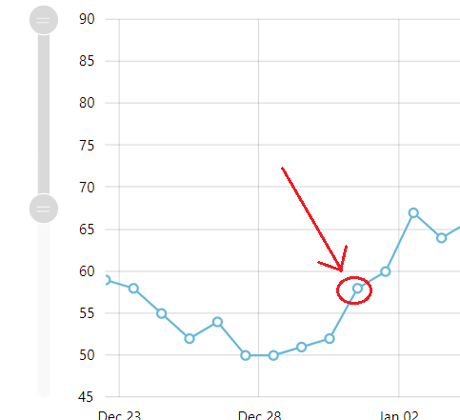

4 – separate landing page for each movie

Can we create two new urls and website landing pages for each of the pairs of charts?

I intend on using the charts for demonstration purposes and consequently would like to avoid using my personal domain and site to host the charts. Can two additional websites / app be created on python anywhere so each movie has its pair of charts on separate landing pages?